**Multi Maps Tableau**

**Name:** Venkata Sarath Chandra Muktevi

**Date:** 06/26/2019

**Part 1:**

1. Screenshot after filtering the states is:

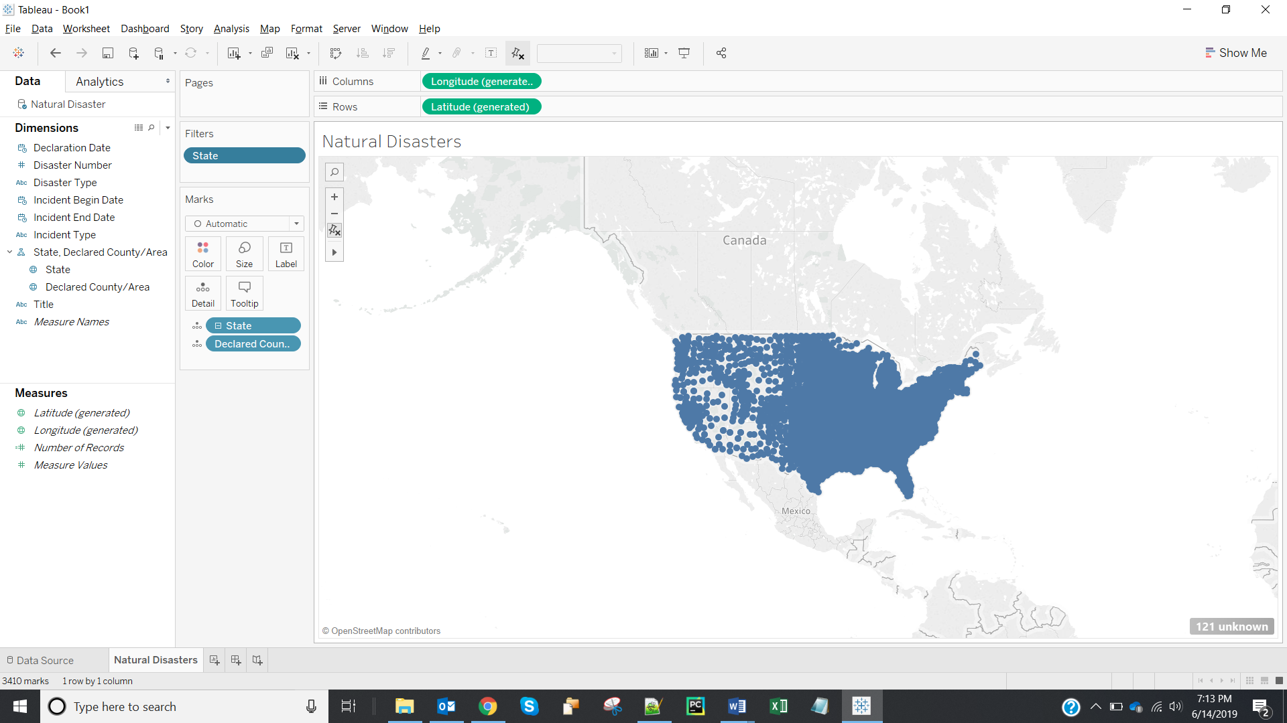

1. Screenshot of the map displaying ‘Number of Records’ as tooltip along with other tooltip fields:

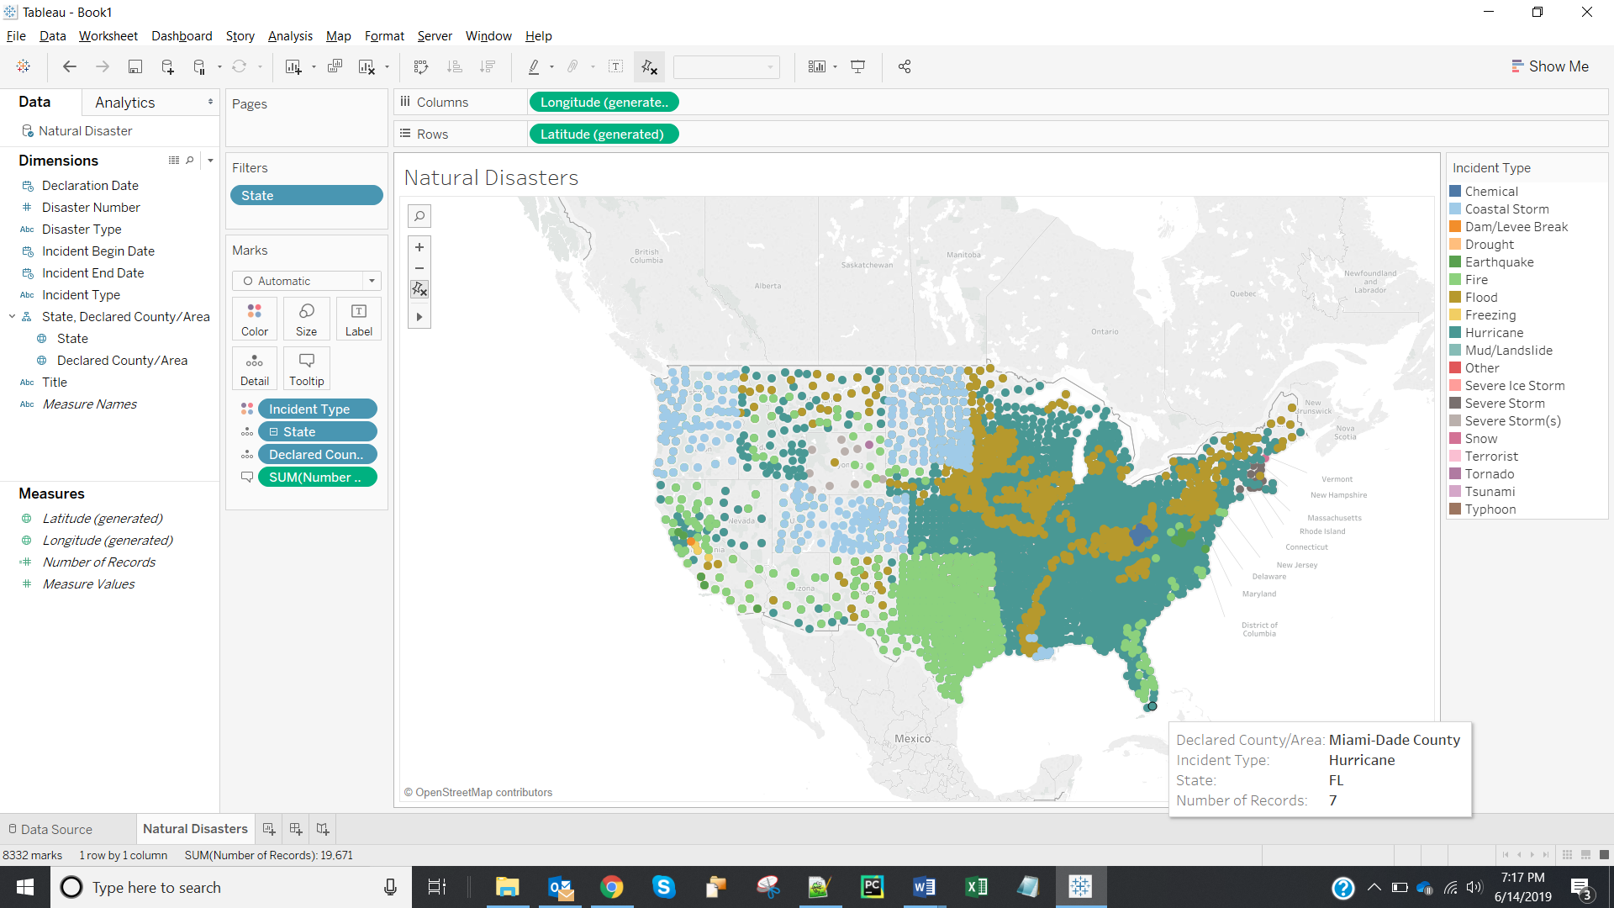

1. Screenshot of Workbook:

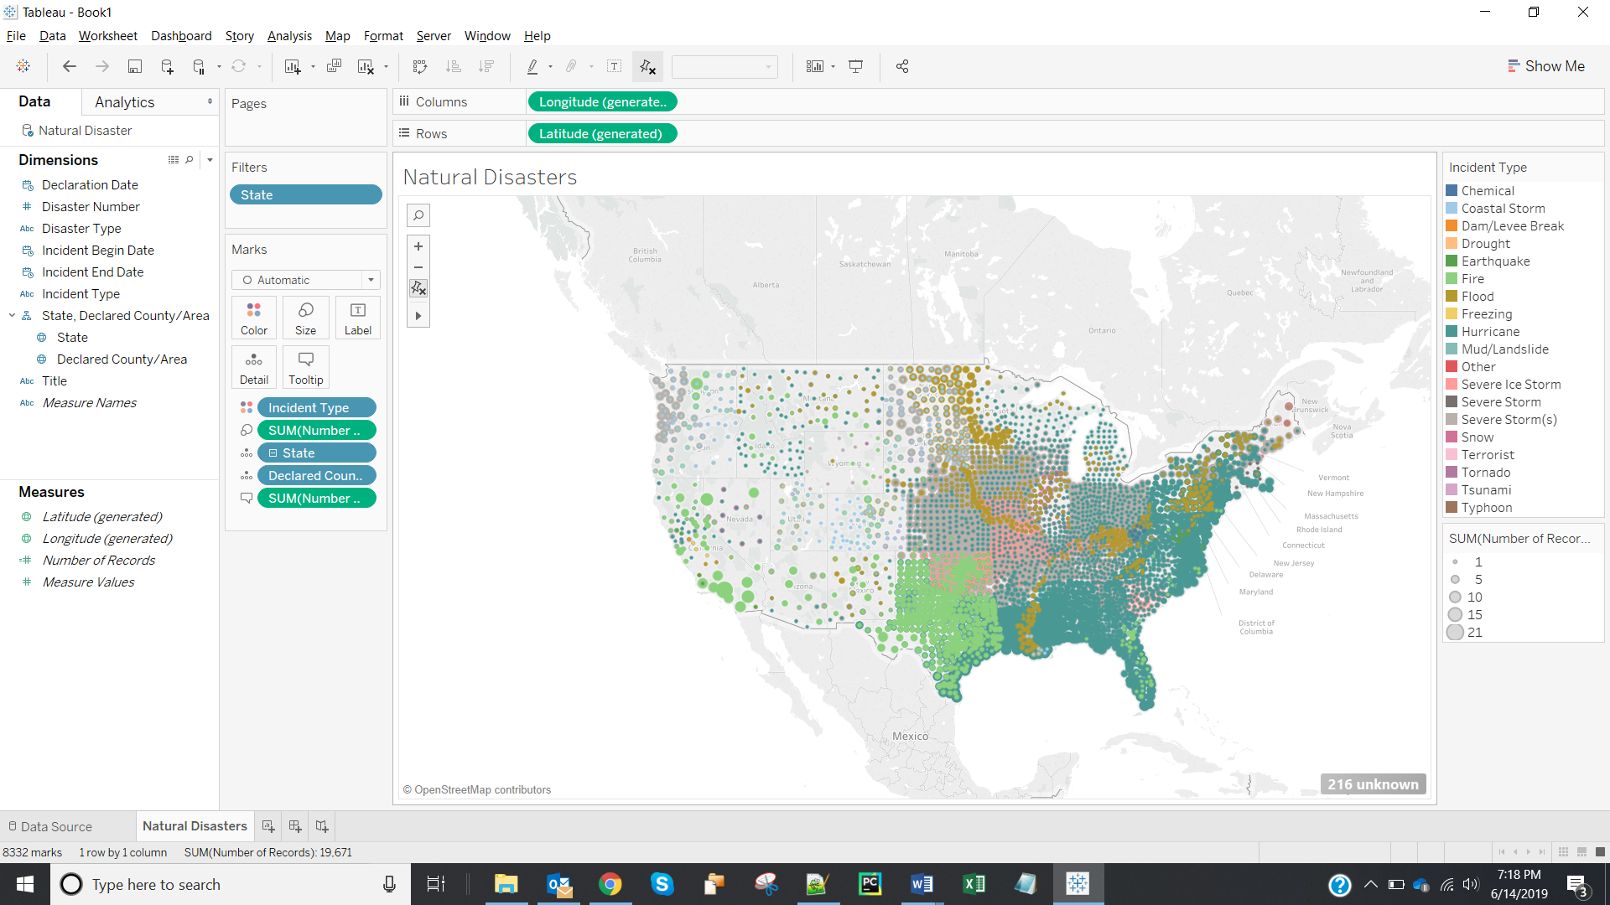

1. Screenshot of workbook displaying ‘Incident Type’ and ‘State’ as a quick filter is:

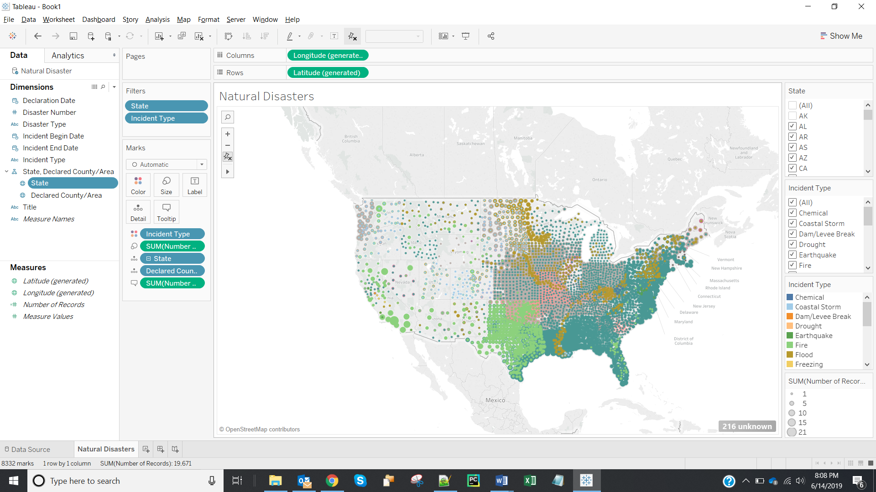

1. As per the map, the most prevalent disaster in Texas is **Fire** and in Alabama it is **Hurricane.**
2. As we have filtered out the states (AK, HI, GU, VI, PR, MP) using filter on states. So, we are not able to see the Alaska and Hawaii.
3. We have visually encoded different disasters using **color (Option -c)**.
4. We have visually encoded number of disaster incidents using **size.**

**Part-2:**

1. Name of all the refineries and the associated counties and states:

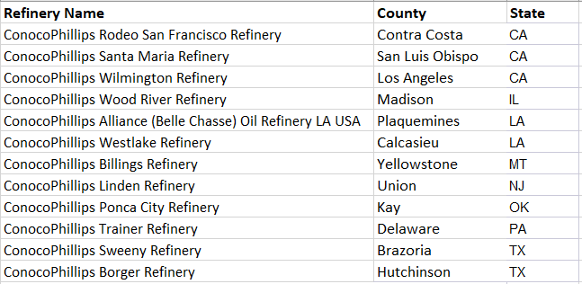

1. Screenshot showing refineries and disasters on the map:

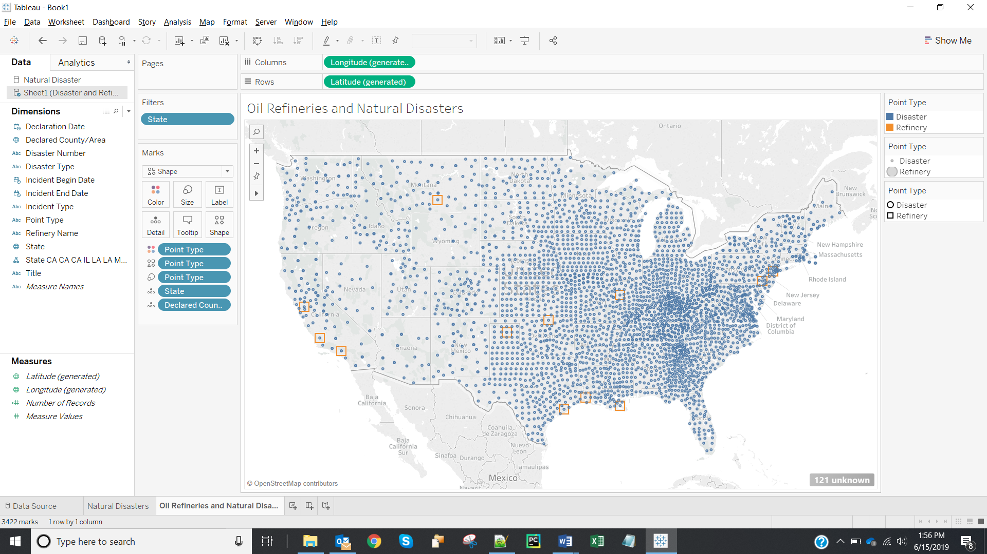

1. Screenshot displaying disasters and refineries in new color and shape is:

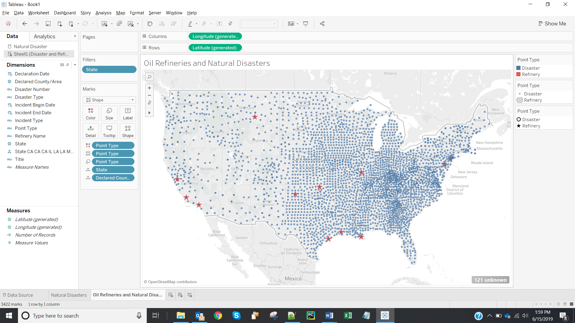

1. States in which ConocoPhillips Energy Company has refineries are **California, Illinois, Louisiana, Montana, New Jersey, Oklahoma, Pennsylvania, Texas.**

**Part 3:**

1. Screenshot showing disasters only in the states where ConocoPhillips Energy has its refineries:

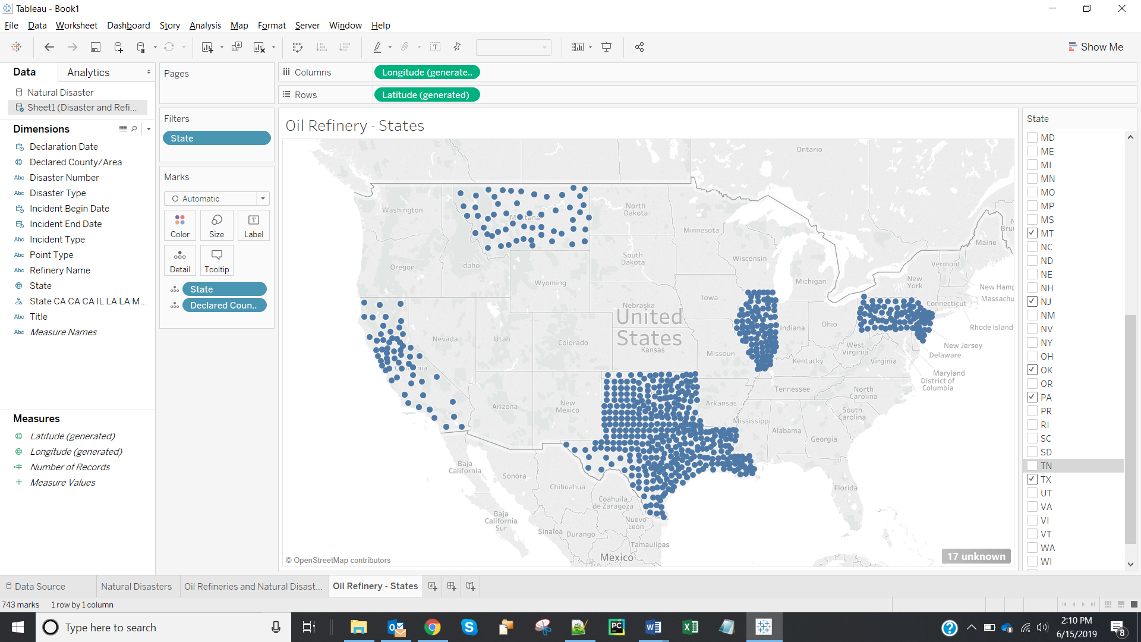

1. Screenshot showing disasters (in different colors) and oil refineries (after annotating):

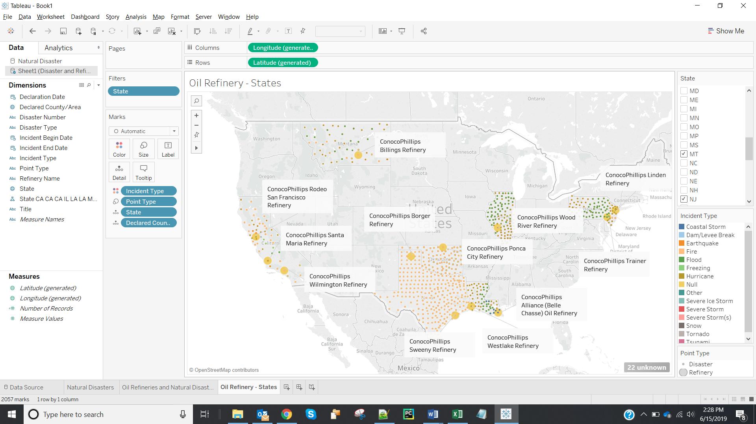

1. The disasters that are impacting the states Pennsylvania (PA) and New Jersey (NJ) are below:

|  |
| --- |
| SEVERE WINTER STORM |
| SEVERE STORMS, TORNADOES, AND FLOODING |
| HURRICANE SANDY |
| SEVERE STORMS AND STRAIGHT-LINE WINDS |
| SEVERE STORM |
| REMNANTS OF TROPICAL STORM LEE |
| SEVERE STORMS AND FLOODING |
| TROPICAL STORM LEE |
| HURRICANE IRENE |
| SEVERE WINTER STORM AND SNOWSTORM |
| SEVERE WINTER STORMS AND SNOWSTORMS |
| SNOWSTORM |
| SEVERE STORMS AND FLOODING ASSOCIATED WITH TROPICAL DEPRESSION IDA AND A NOR'EAS |
| WARREN GROVE FIRE |
| SEVERE STORMS AND INLAND AND COASTAL FLOODING |
| SEVERE STORMS, FLOODING, AND MUDSLIDES |
| HURRICANE KATRINA EVACUATION |
| HURRICANE KATRINA |
| SEVERE STORMS AND FLOODING ASSOCIATED WITH TROPICAL DEPRESSION FRANCES |
| TROPICAL DEPRESSION IVAN |

**Part 4:**

1. Screenshot showing the 4 created calculated fields is:

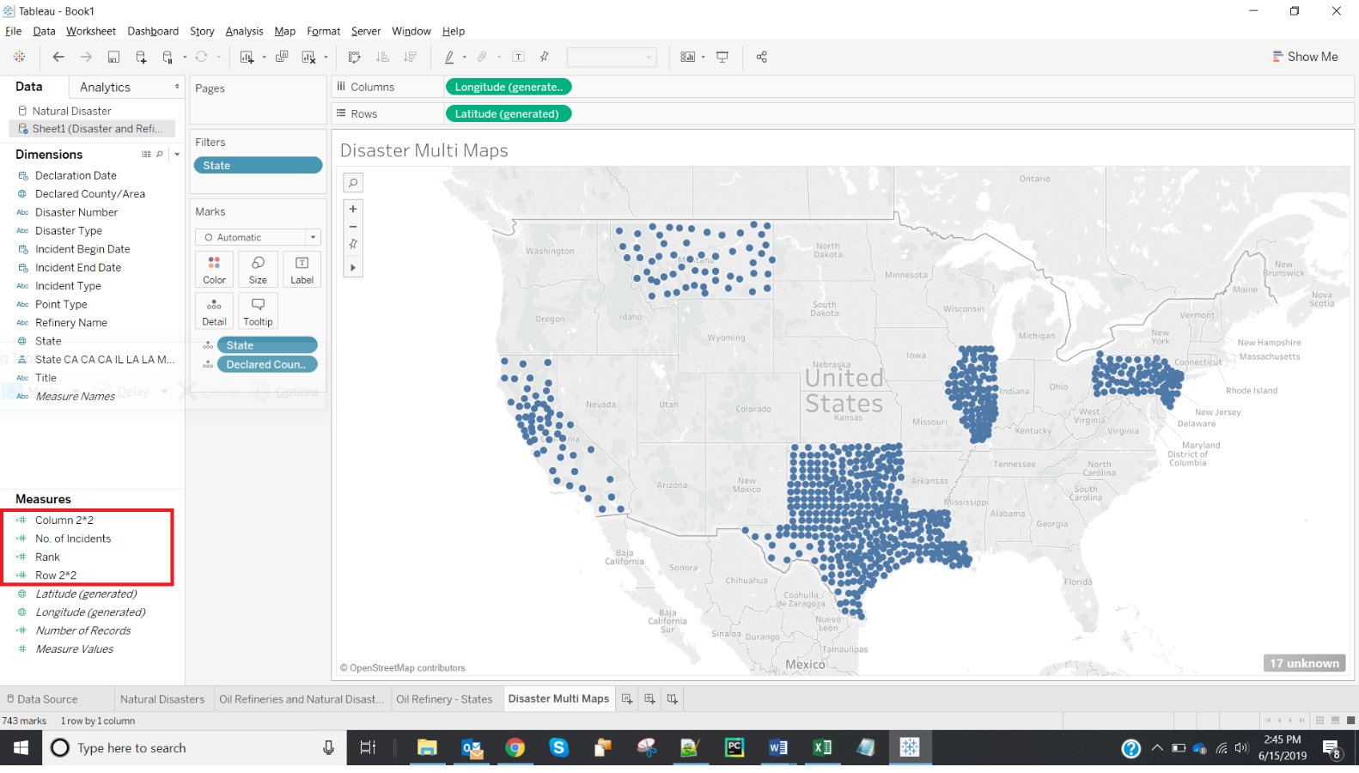

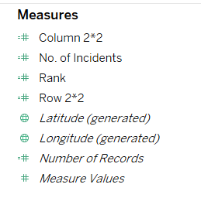

1. **Hurricane** that occurred at **Mono County** is ranked 1.

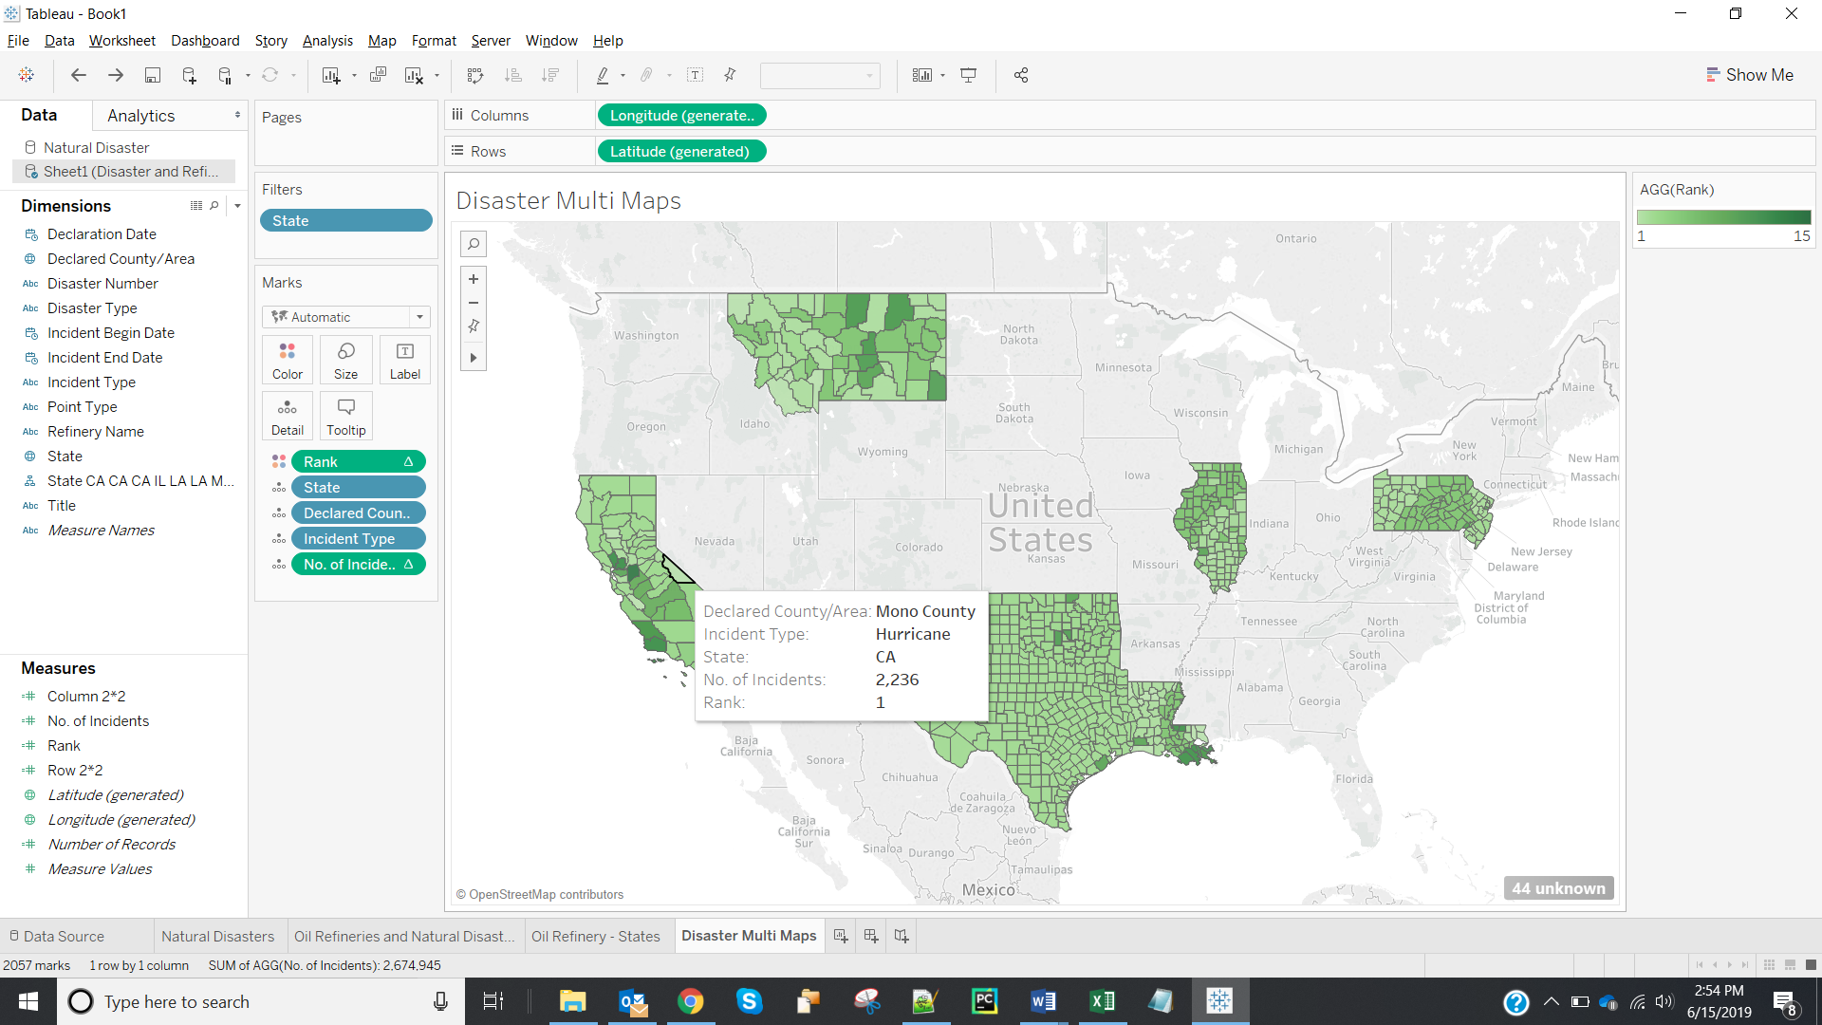

1. Screenshot of Multimap is:

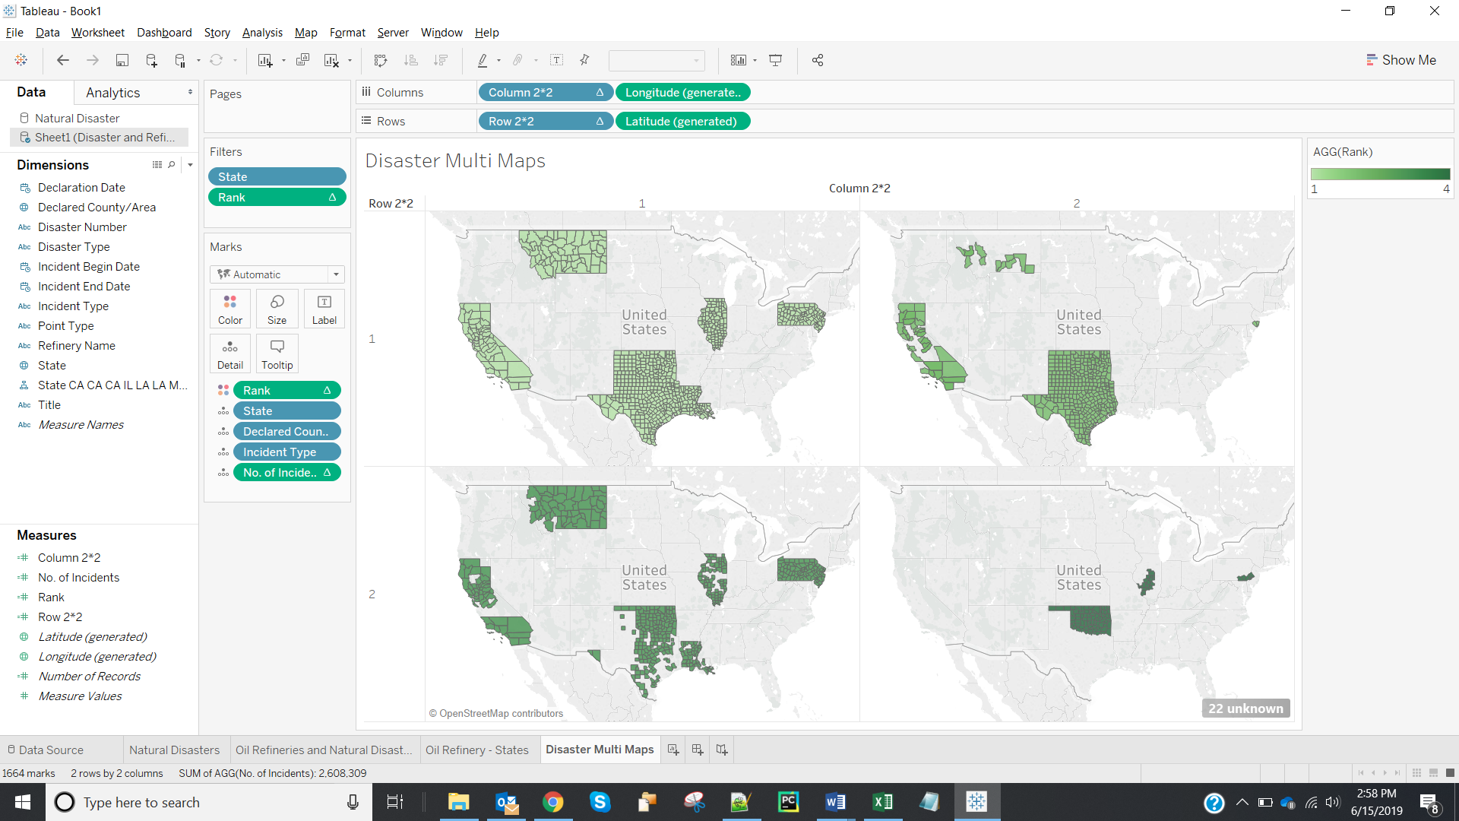

1. Screenshot of Multimaps showing labels:

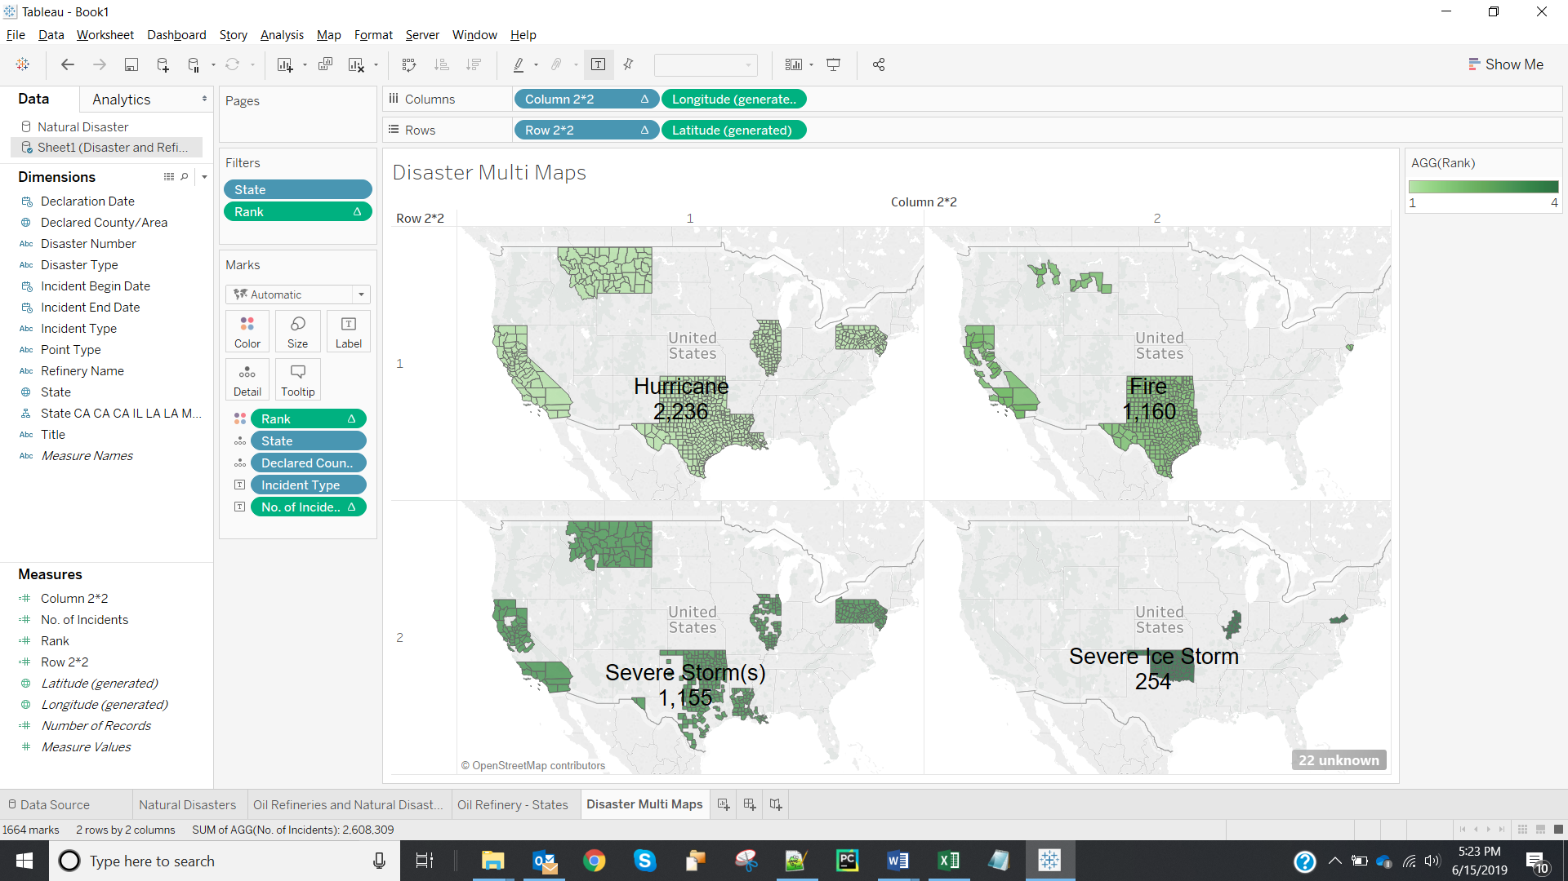

1. Fields that cannot be aggregated will be added to Dimension pane, in our case as all the calculated fields are numeric ie., metrics (they can be aggregated or measured or used for mathematical operations). Hence, they got added to the Measures pane.

**Part 5:**

1. Story Data points:

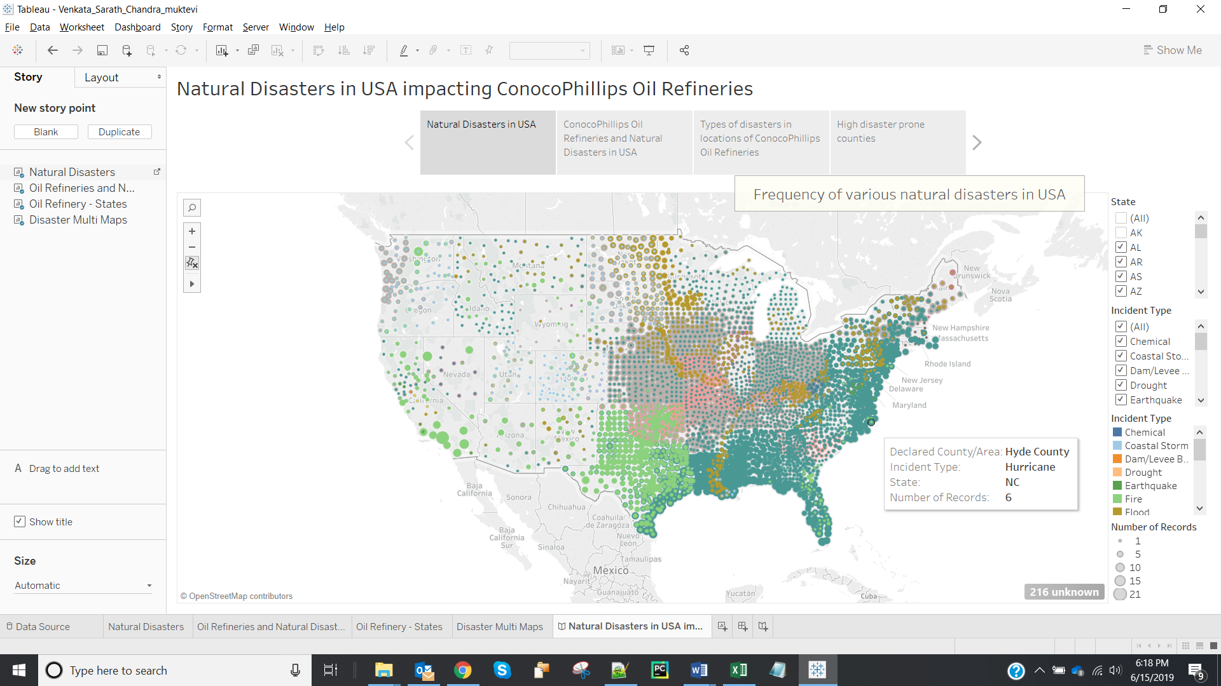

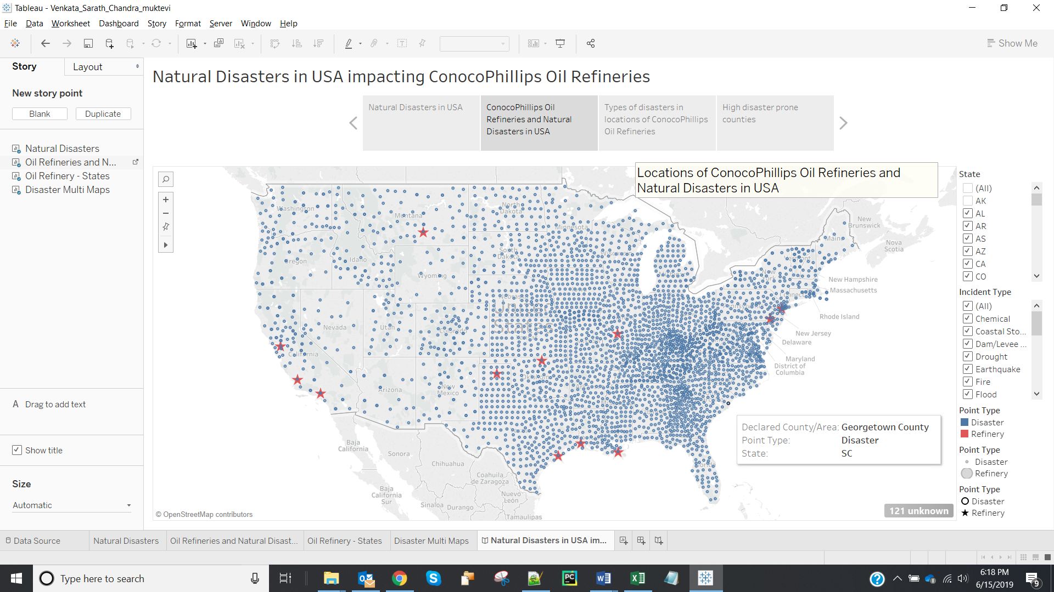

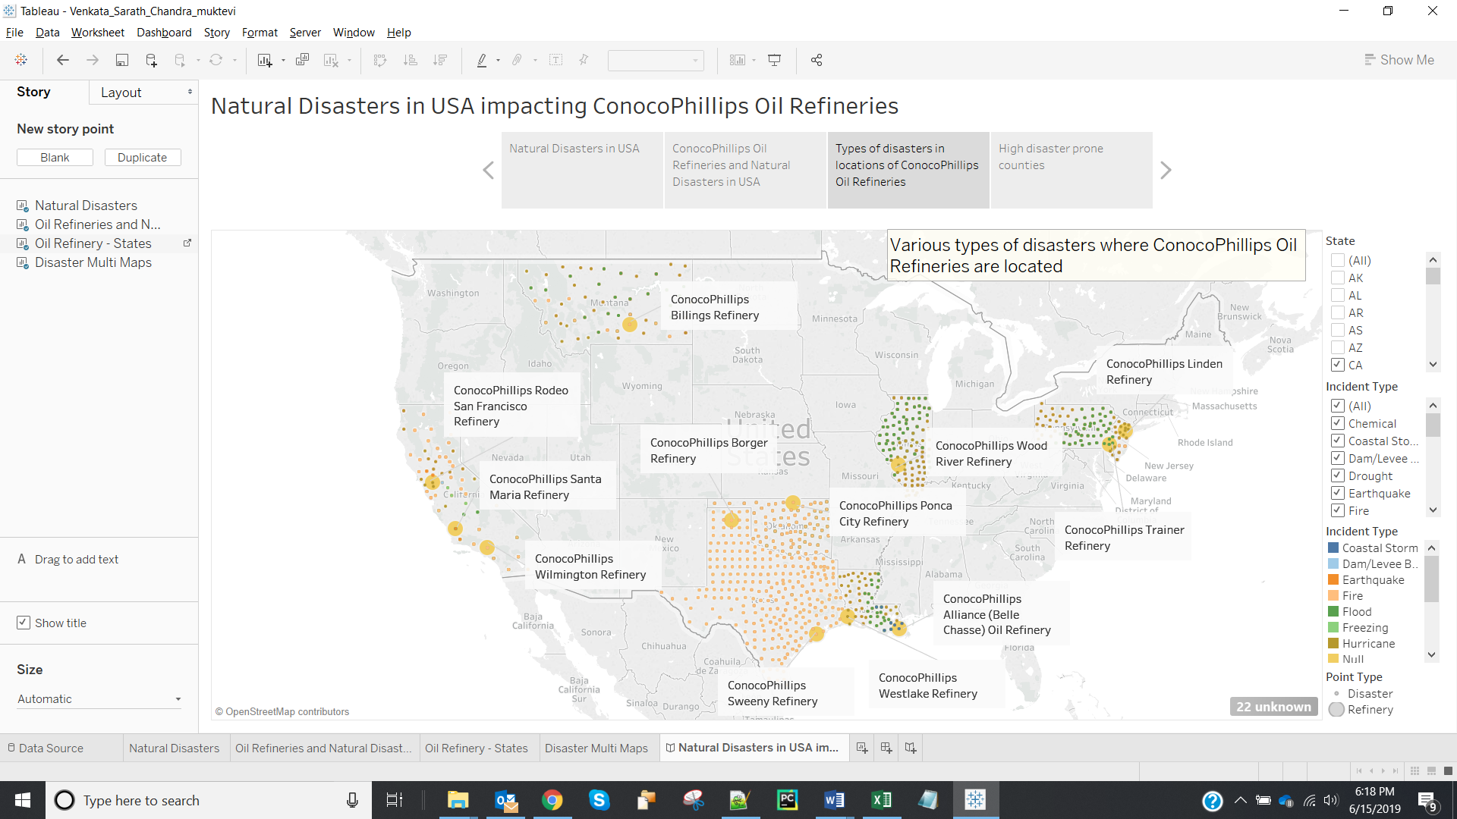

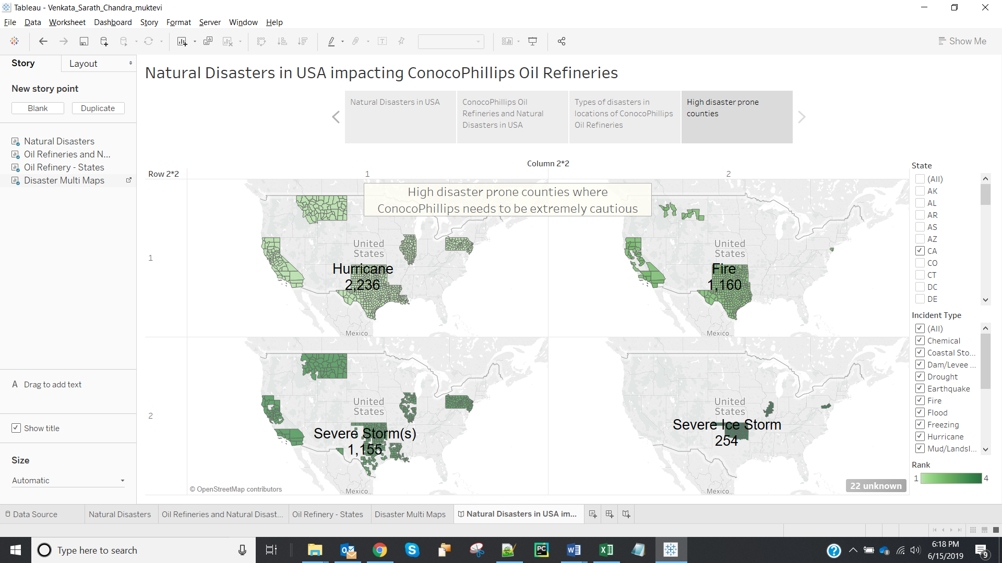

1. I used **Logical Rhetoric** for the story. Based on the frequency and severity of incidents at locations shown in maps, I would be suggesting ConocoPhillips Management to be extremely cautious in the high natural disaster-prone counties.